Project Design Phase-II
Data Flow Diagram & User Stories
Date | 29 September 2026
Project Name | Metro Ticket Generating System in ServiceNow
Maximum Marks | 4 Marks

Data Flow Diagrams:
The DFD represents how metro booking information moves through the ServiceNow solution: passenger inputs enter through the Service Catalog, fare information is calculated, Flow Designer processes the request, booking data is stored in the custom Metro Database table, and QR ticket information is presented for passenger and station-side validation.
DFD Level 0 - Context Diagram
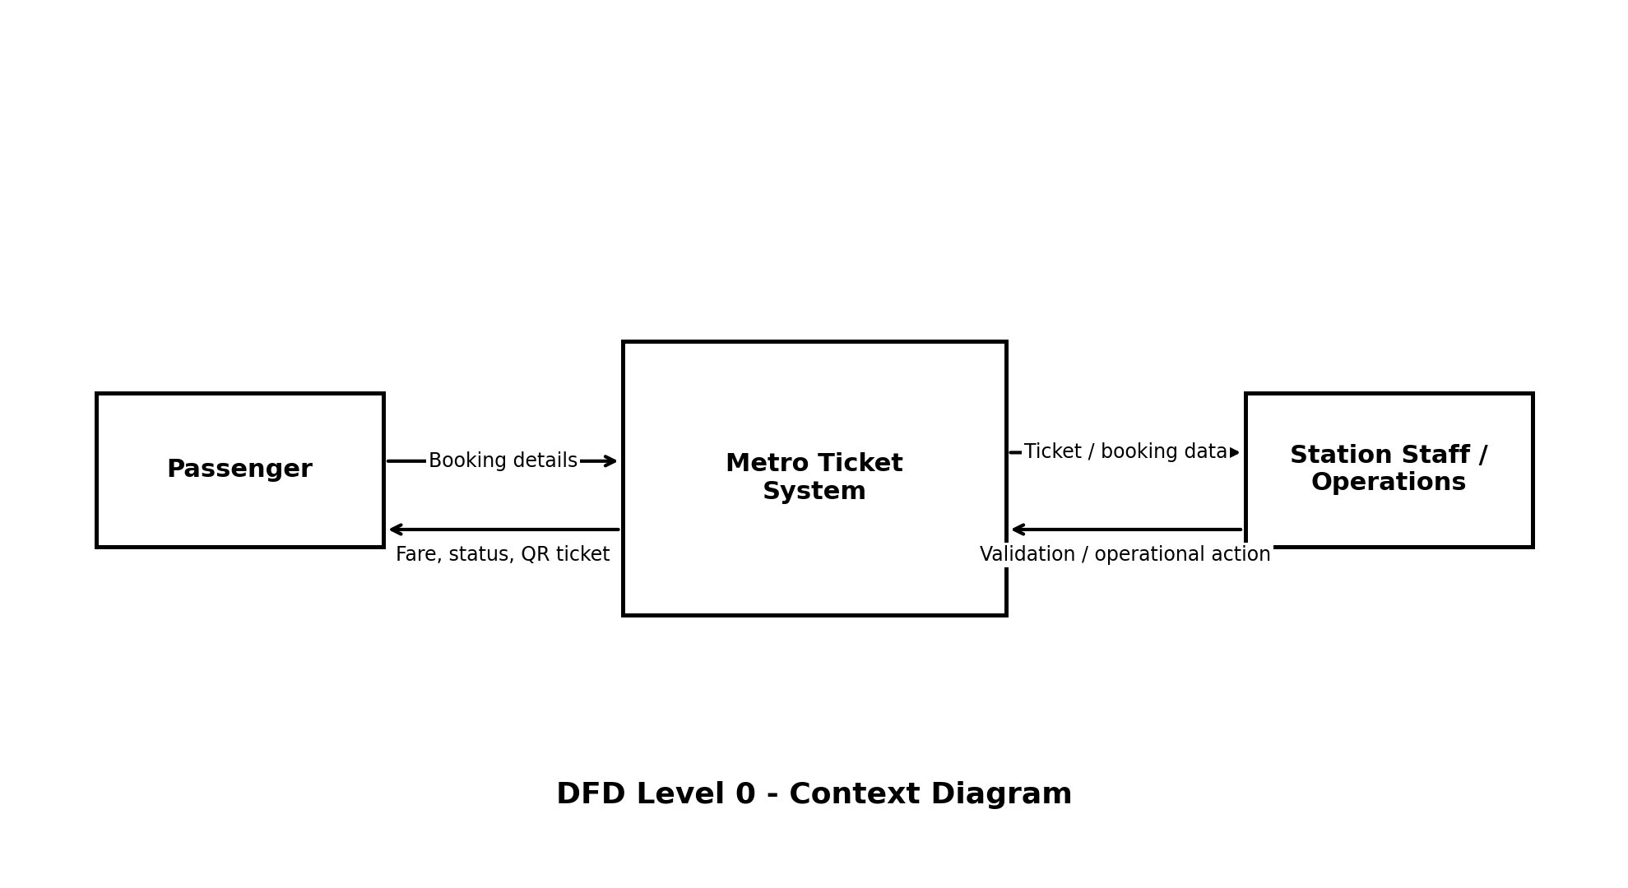
Level 0 treats the Metro Ticket Generating System as one process. The Passenger supplies booking details and receives fare/status/QR output. Station Staff or Metro Operations receive ticket information for validation and may perform operational actions.
DFD Level 1 - Detailed Data Flow
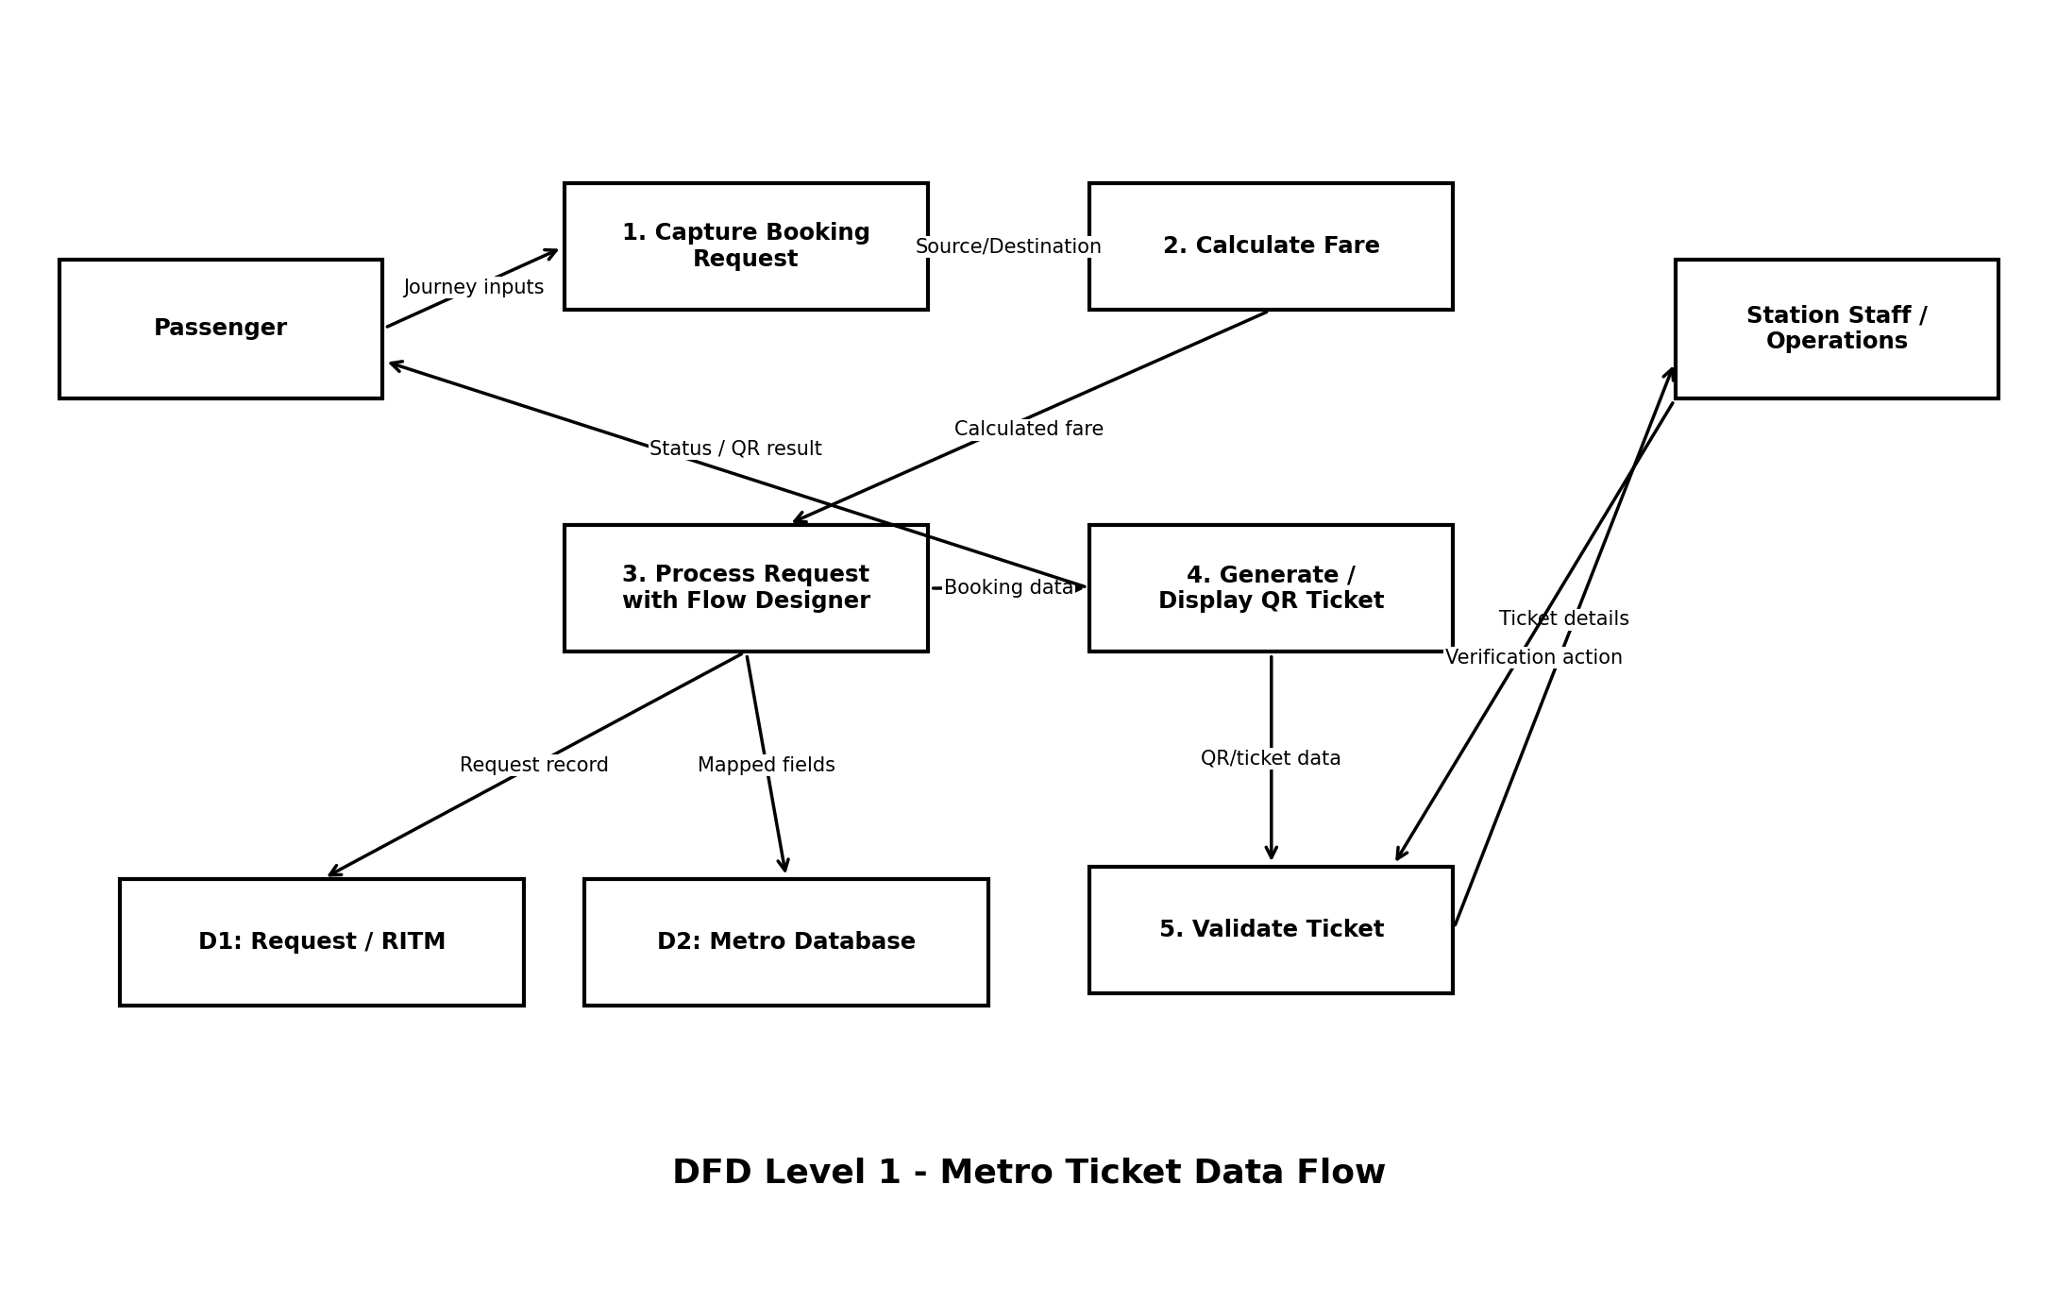
Level 1 Process Description
No. | Process | Data Flow / Function
1 | Capture Booking Request | Collect Source, Destination, Passenger Type and Number of Tickets from the Service Catalog.
2 | Calculate Fare | Apply source-destination fare mapping and ticket quantity rules to determine the fare.
3 | Process Request with Flow Designer | Read catalog variables, execute the automation path, create/update records and trigger required downstream actions.
4 | Generate / Display QR Ticket | Create or prepare QR ticket data and render it through a Service Portal-compatible widget / spModal experience.
5 | Validate Ticket | Provide ticket information to station staff or operations for verification.

Data Stores
• D1 - Request / RITM: Maintains the ServiceNow request and request-item context created when the passenger submits the catalog item.
• D2 - Metro Database: Custom structured storage for metro ticket / booking details mapped from the submitted catalog variables.
User Stories
The user stories below translate the implemented and planned functional requirements into user-centered tasks. Priority and release values are aligned with the project's four-phase roadmap rather than claiming features that were not implemented.
User Type | Functional Requirement (Epic) | User Story No. | User Story / Task | Acceptance Criteria | Priority | Release
Passenger | Ticket Booking | USN-1 | As a passenger, I can open the metro booking catalog item and enter my journey details. | Source, Destination, Passenger Type and Number of Tickets can be entered successfully. | High | Phase 1
Passenger | Fare Calculation | USN-2 | As a passenger, I can view the calculated fare before finalizing the booking. | Correct fare is calculated from the configured route/fare logic and ticket count. | High | Phase 2
Passenger | Ticket Submission | USN-3 | As a passenger, I can submit my metro ticket request through the ServiceNow portal. | A request / RITM is created and the booking enters the configured Flow Designer process. | High | Phase 2
Passenger | Request Tracking | USN-4 | As a passenger, I can track the status of my submitted booking request. | The request is visible with an understandable processing status. | High | Phase 3
Passenger | Digital Ticket | USN-5 | As a passenger, I can open a QR-based digital ticket after the booking is processed. | The QR/ticket view loads successfully in the portal and displays the booking proof. | High | Phase 3
Station Staff | Ticket Validation | USN-6 | As station staff, I can view or verify the passenger's ticket information from the QR ticket. | Ticket details correspond to the stored booking data and can be validated. | High | Phase 3
Metro Operations | Booking Records | USN-7 | As an operations user, I can access structured metro booking records for operational use. | Mapped booking fields are stored in the custom Metro Database table. | High | Phase 2
Metro Operations | Workflow Monitoring | USN-8 | As an operations user, I can inspect Flow Designer execution details when a booking fails. | Execution details identify the failed step, condition path, input or output involved. | High | Phase 4
Administrator | Access Control | USN-9 | As an administrator, I can configure roles and ACLs to control access to ticket records. | Unauthorized users cannot access protected operational data beyond their permitted role. | High | Phase 4
Administrator | Maintainability | USN-10 | As an administrator, I can maintain the solution primarily through Flow Designer, UI Policies and limited client-side logic. | Core workflow can be understood and modified without unnecessary custom server-side code. | Medium | Phase 4
Passenger | Email/SMS Ticket | USN-11 | As a passenger, I would like to receive my ticket through email or SMS as an additional delivery channel. | Ticket details are delivered through the selected notification channel. | Medium | Future
Passenger | Digital Payment | USN-12 | As a passenger, I would like to pay using UPI/cards/wallets during booking. | Successful payment is confirmed and associated with the ticket request. | Medium | Future

Acceptance Focus
The critical acceptance path is: passenger enters valid journey information -> fare is calculated -> request is submitted -> Flow Designer processes and stores the booking -> QR ticket is displayed -> station-side ticket information can be verified. Debugging of fare mismatches, variable mappings and QR rendering is therefore directly linked to these high-priority user stories.

